Project Planning Phase
Project Planning Template (Product Backlog, Sprint Planning, Stories, Story points)

Date | 19 July 2026
Team ID
Project Name | Nightjar & Co. – MERN BookStore
Maximum Marks | 5 Marks

Product Backlog, Sprint Schedule & Estimation
Sprint | Functional Requirement (Epic) | User Story No. | User Story / Task | Story Points | Priority | Team Member
Sprint-1 | Project Setup | USN-1 | As a developer, I can create the MERN project structure. | 2 | High | Trisha
Sprint-1 | Project Setup | USN-2 | As a developer, I can configure MongoDB and Express.js. | 2 | High | Deepika
Sprint-1 | User Authentication | USN-3 | As a user, I can register for the application. | 3 | High | Sajida
Sprint-1 | User Authentication | USN-4 | As a user, I can log in securely using email and password. | 5 | High | Sajida
Sprint-1 | User Authentication | USN-5 | As a developer, I can encrypt passwords using bcrypt and implement JWT authentication. | 3 | High | Deepika
Sprint-1 | Frontend Setup | USN-6 | As a user, I can access a responsive homepage. | 1 | Medium | Anjali
Sprint-2 | Book Management | USN-7 | As a user, I can browse the list of books. | 3 | High | Anjali
Sprint-2 | Book Management | USN-8 | As a user, I can search books by title. | 2 | High | Sajida
Sprint-2 | Book Management | USN-9 | As a user, I can filter books by category. | 2 | Medium | Anjali
Sprint-2 | Shopping Cart | USN-10 | As a user, I can add books to the shopping cart. | 5 | High | Sajida
Sprint-2 | Book Details | USN-11 | As a user, I can view detailed information about a selected book. | 2 | Medium | Anjali
Sprint-2 | Testing | USN-12 | As a developer, I can test APIs and fix bugs before deployment. | 2 | High | Pranathi
Sprint Summary
Sprint 1 Story Points
2 + 2 + 3 + 5 + 3 + 1 = 16 Story Points
Sprint 2 Story Points
3 + 2 + 2 + 5 + 2 + 2 = 16 Story Points
Total Story Points = 32

Project Tracker
Sprint | Total Story Points | Duration | Sprint Start Date | Sprint End Date (Planned) | Story Points Completed | Sprint Release Date (Actual)
Sprint-1 | 16 | 7 Days | 15 Feb 2025 | 21 Feb 2025 | 16 | 21 Feb 2025
Sprint-2 | 16 | 7 Days | 22 Feb 2025 | 28 Feb 2025 | 16 | 28 Feb 2025

Velocity Calculation
Total Story Points Completed = 32
Number of Sprints = 2
Velocity = Total Story Points ÷ Number of Sprints
Velocity = 32 ÷ 2 = 16 Story Points per Sprint

Average Velocity
Total Story Points | Number of Sprints | Velocity
32 | 2 | 16 Story Points / Sprint
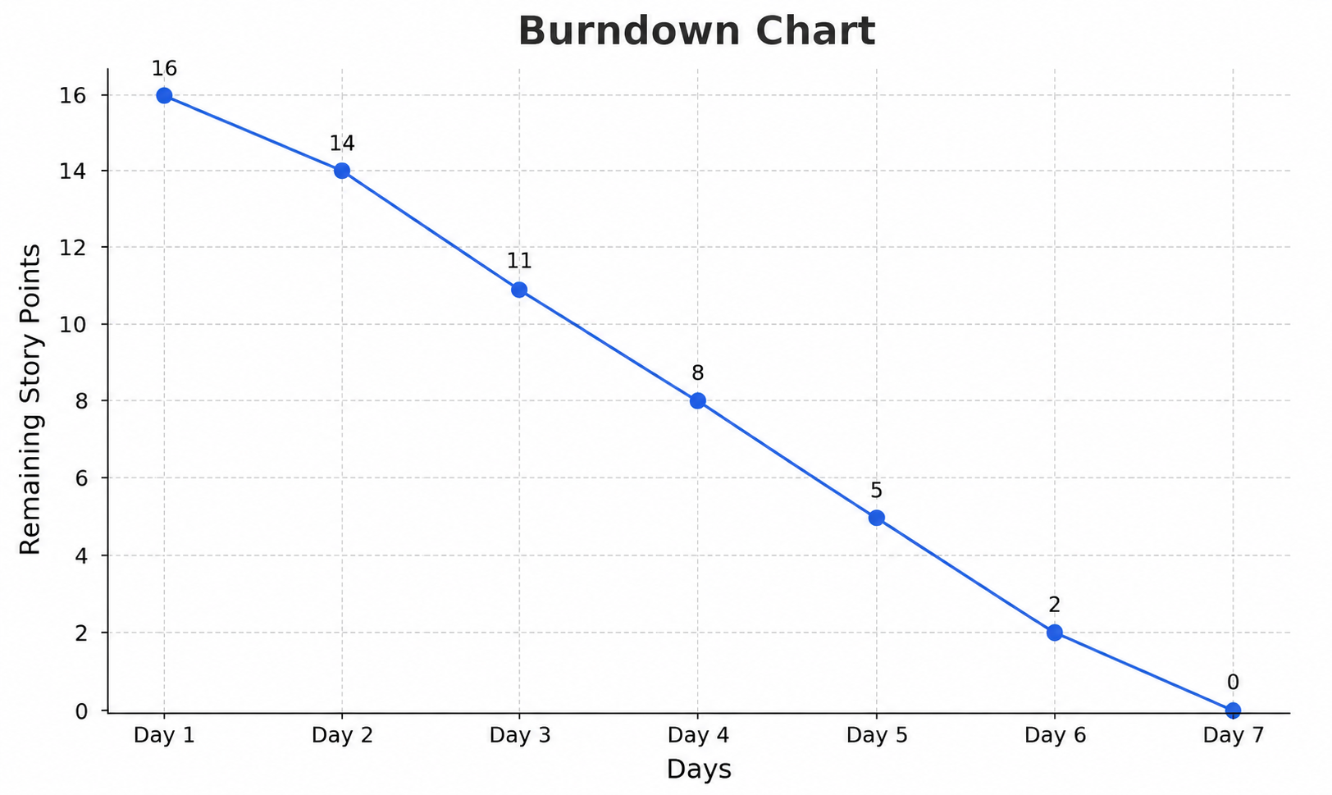
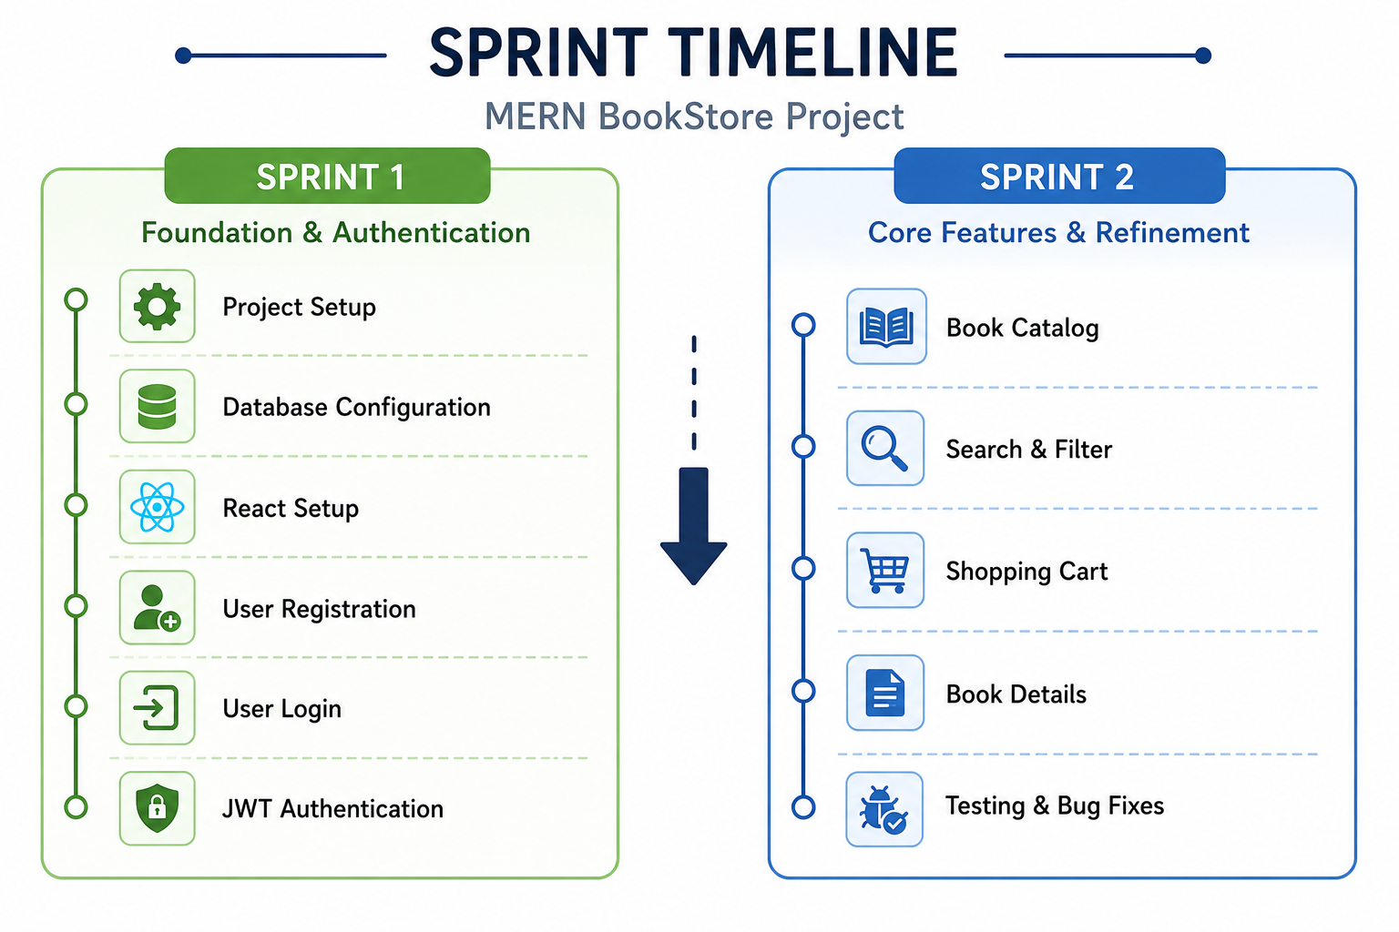

Suggested Team Member Allocation
- Trisha (Team Lead): Project planning, coordination, project setup
- Sajida: Authentication, search functionality, shopping cart
- Anjali: Frontend UI, homepage, book catalog, book details
- Deepika: Backend APIs, MongoDB integration, JWT and bcrypt
- Pranathi: Testing, bug fixing, documentation

